<https://fonts.google.com/>

<https://www.color-hex.com/>

<https://github.com/rajeshThappeta/ecomm-static-demo/tree/master/Images>

1. Download and install VS
2. Install live server extension in VS
3. localhost is the domain name for 127.0.0.1
4. <meta name="viewport" content="width=device-width, initial-scale=1.0”>
5. box-sizing: border-box;
6. font-family: "Oswald", serif;

when Oswald not available it will fall back to font safe serif

1. <https://hslpicker.com/#ff3300>
2. Css variable name needs to start with –
3. h1{
4. color:var(--color-one)
5. }
6. CSS Flex

13

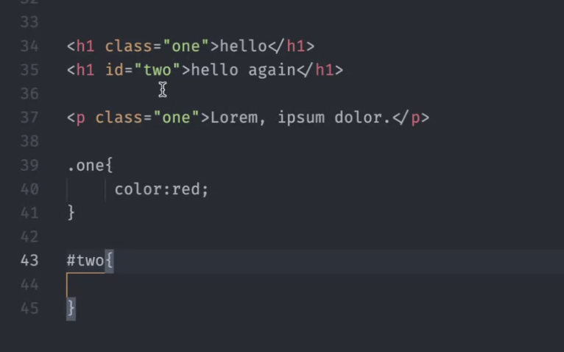

Id attribute cannot be duplicated

But class attribute can we reused as many times as you want to any number of elements

**Jan 7**

Buttons of three types – type=botton , submit, reset

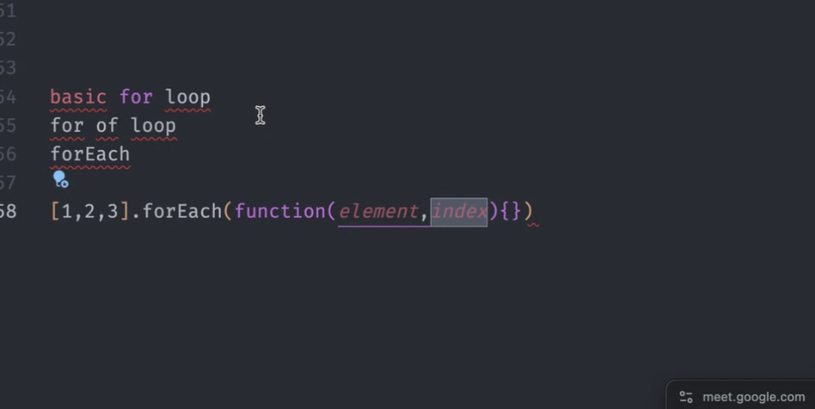

Arrow Functions

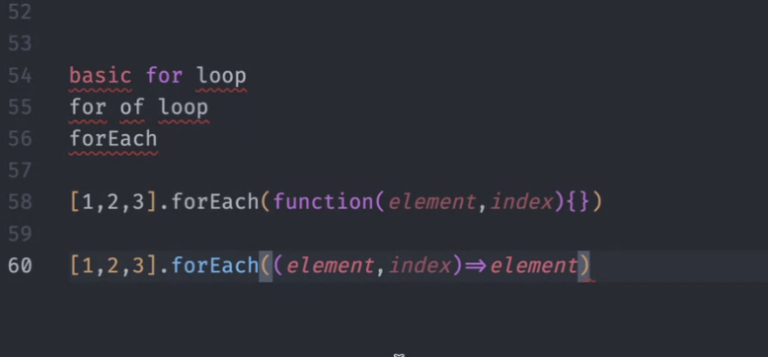

[1,2,3].foreach((element, index)=>element))

Most of the predefined functions in React, Angular contain one liners in the body. So we use Arrow Functions a lot.

TODO: Compare two passwords. Display a error message when passwords don’t match

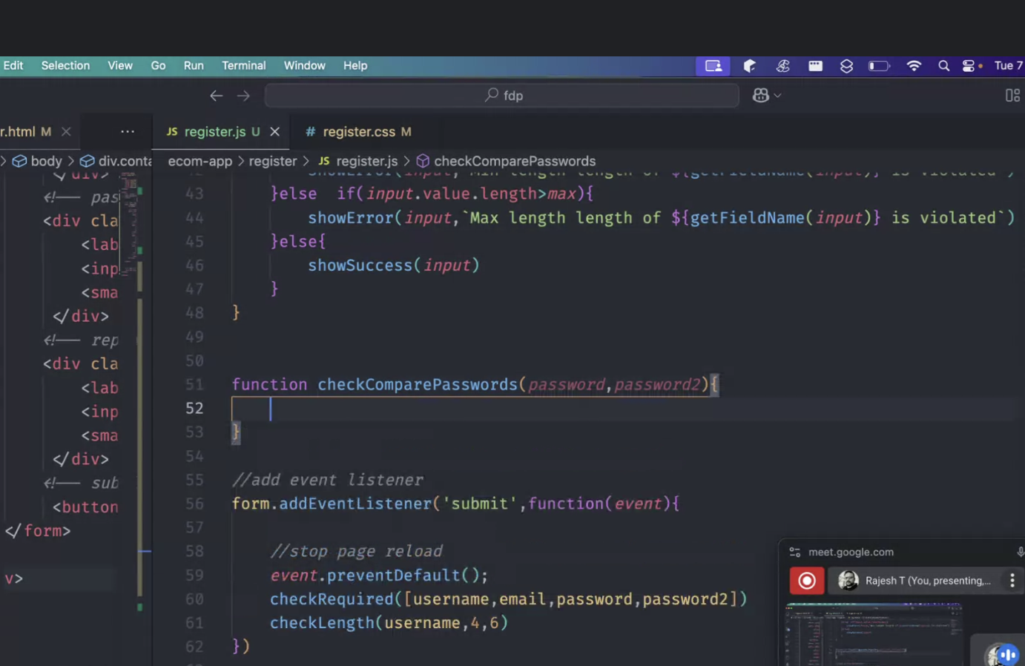

ES6-DEMO

Variable hoisting in Java Script

PROMISES

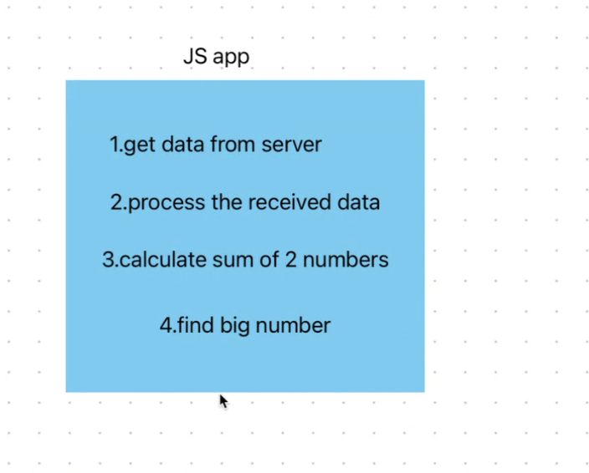

Server availability

Network issues

Internet bandwidth

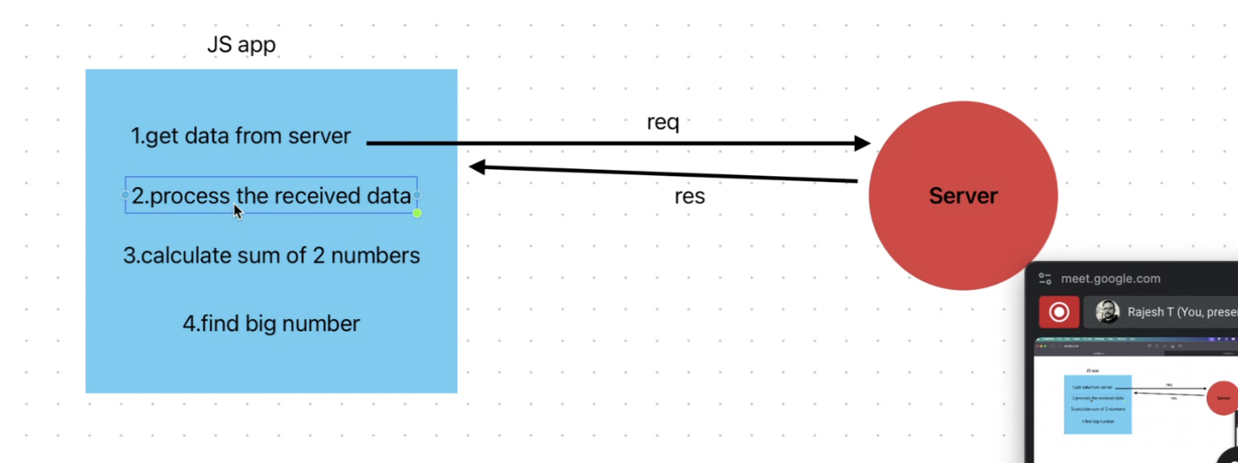

Synchronous are great choices when tasks are dependent on each other

In client server communication Asynchronous is very important

Within the waiting period of promise … we can do other tasks also at the same time

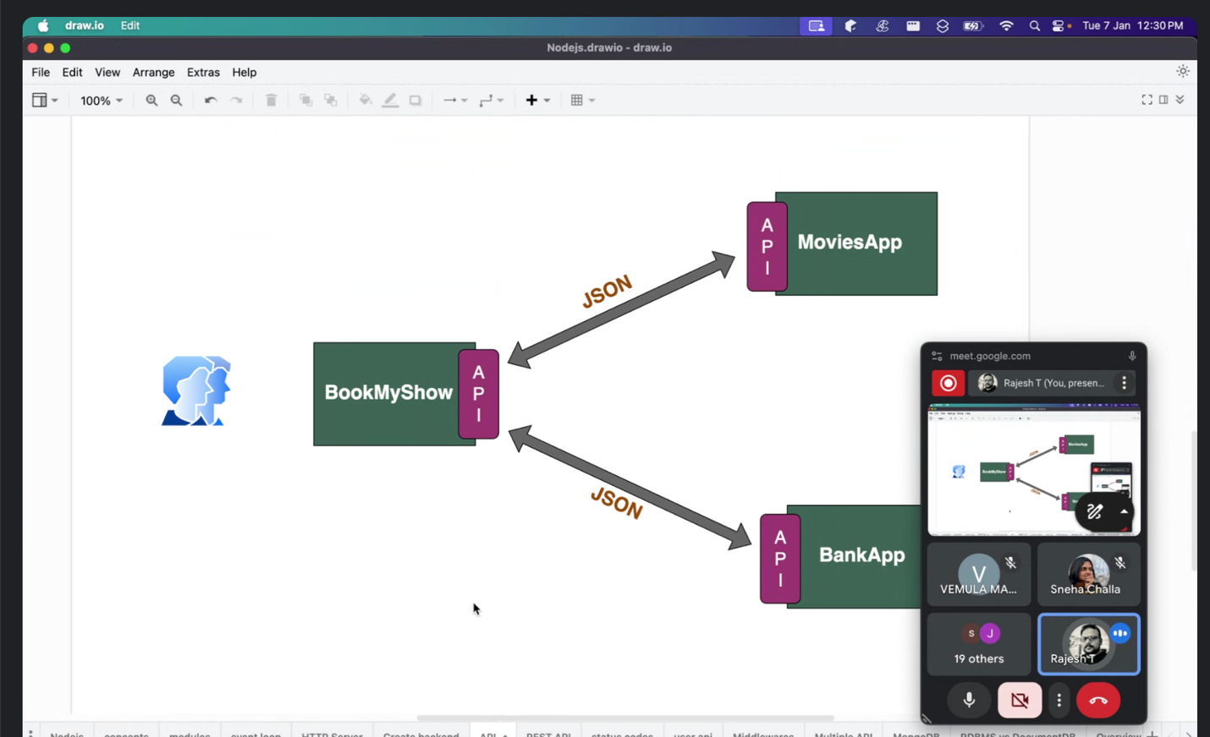

How can a JAVA application speak to python application or a java script application?

API is like the translator

API establish communication between different applications (whether the application may be same tech or different tech)

API converts into neutral data format before sending to another application. Xml and json are neutral data formats. They are understood by every technology.

JSON – any tech can parse and understand this data structure

XML can be lengthy and clumpsy.

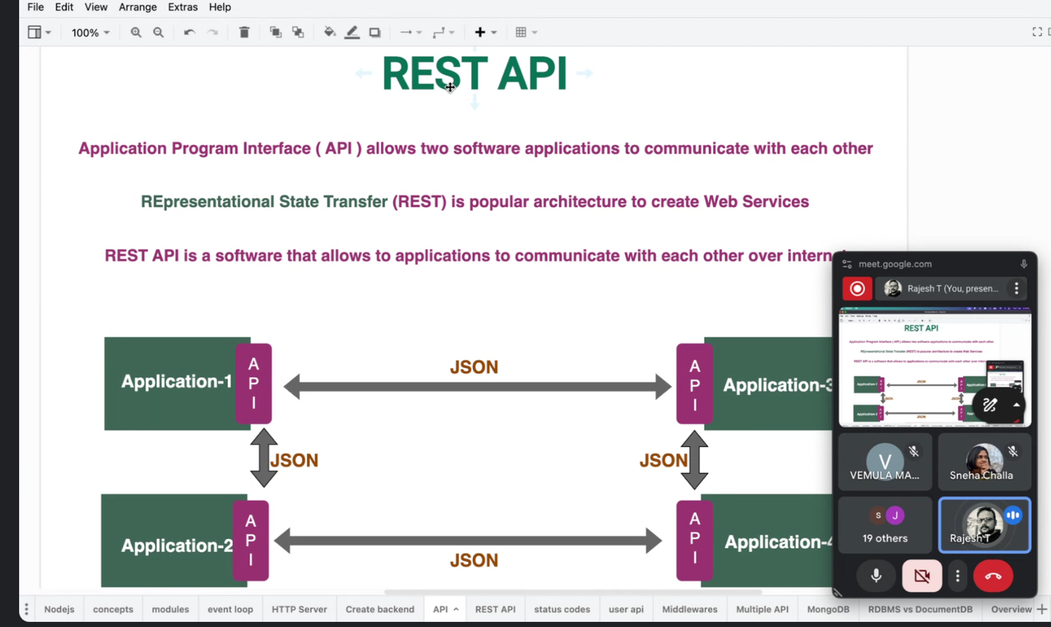

APIs are part of backend

REST APIs are what we use for mobile and web applications.